

**Assignment No: 02**

Submitted by:

Name : Haseeb Ullah

ID: F20232661009

Section: V21

Submitted to:

Name: Sir Raiz Ahmed

Programming fundamental Lab

**Address:** C-II Block C 2 Phase 1 Johar Town, Lahore, Punjab 54770.

University of Management & Technology.

**Programming Fundamentals in C++ - If-Else Statements**

**Q1. Simple Questions: CLO [1]**

**(a)**

1. Write a C++ program that takes an integer input from the user and prints "Even" if the number is even and "Odd" if it's odd.

|  |
| --- |
| #include <iostream>  using namespace std;  /*a) Write a C++ program that takes an  integer input from the user and prints  "Even" if the number is even and "Odd" if it's odd.*/  int main(){  int num;  cout << "Enter the Number: ";  cin >> num;  if (num % 2 == 0)  {  cout << "Number is Even: " << num << endl;  }else  {  cout << "Number is Odd: " << num << endl;  }  return 0;  } |

Output

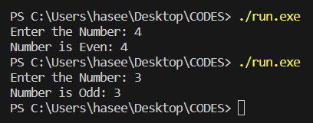

**(b)**

1. Develop a C++ program that checks whether a given character is a vowel or a consonant. Display an appropriate message based on the input.

|  |
| --- |
| #include <iostream>  using namespace std;  /* Develop a C++ program that checks whether a given character is a vowel or a consonant.   Display an appropriate message based on the input. */  int main(){      char character;      cout << "Enter the character: ";      cin >> character;      if (character == 'a' || character == 'e' || character == 'i' || character == 'o' || character == 'u')      {          cout << "its a volwel. " << endl;      }        else      {          cout << "Its not a vowel."<< endl;      }          return 0;  } |

**Output**

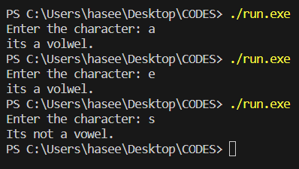

**(c)**

Create a C++ program to find the maximum of two numbers entered by the user. Use an if-else statement to determine and display the result.

|  |
| --- |
| #include <iostream>  using namespace std;  int main(){  int num, num2;  cout << "Enter the Number ";  cin >> num;  cout << "Enter the second number ";  cin >> num2;  if(num > num2){  cout << "the first number is maximum";  }else{  cout << "the second number is maximum";  }  return 0;  } |

**Output**

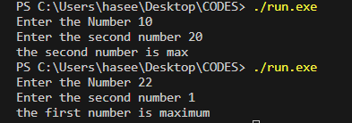

**Q2. Average Difficulty Questions: CLO [2]**

1. Write a C++ program that calculates the grade of a student based on the percentage entered by the user. Use if-else statements to assign grades (A, B, C, D, or F) according to predefined criteria.

|  |
| --- |
| #include <iostream>  using namespace std;  int main(){  int total{};  int marks{};  float percentage;  cout << "Enter the Obtained marks: ";  cin >> marks;  cout << "Enter the total marks: ";  cin >> total;  percentage = static_cast<float>(marks)/static_cast<float>(total) * 100;  if(percentage > 90){  cout << "Grade A";  }else{  cout << "soon on";  }  return 0;  } |

**Output**

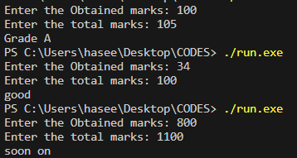

1. Implement a C++ program that determines if a given year is a leap year or not. Display a message indicating whether it's a leap year or not.

|  |
| --- |
| #include <iostream>  using namespace std;  // Implement a C++ program that determines  // if a given year is a leap year or not.  // Display a message indicating whether it's a leap year or not.  int main(){  int year;  cout << "Enter the year: ";  cin >> year;  if(year % 4 == 0 || year % 400 == 0 && year % 100 != 0){  cout << "Its leap year.";  }else{  cout << "Its not leap year.";  }  return 0;  } |

**Output**

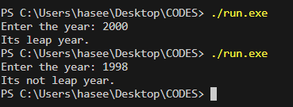

1. Develop a C++ program that takes three integers as input from the user and prints them in ascending order using if-else statements.

|  |
| --- |
| #include <iostream>  using namespace std;  int main(){  int one, two, three;  cout << "Enter 1st number: ";  cin >> one;  cout << "Enter 2nd number: ";  cin >> two;  cout << "Enter 3rd number: ";  cin >> three;  if(one < two && one < three){  cout << one << " ";  if(two < three){  cout << two << " " << three;  }else{  cout << three << " " << two;  }  }else if(two < one && two < three){  cout << two << " ";  if(one < three){  cout << one << " " << three;  }else {  cout << three << " " << one;  }  }else if(three < one && three < two){  cout << three << " ";  if(one < two){  cout << one << " " << two;  }else{  cout << two << " " << one;  }  }  return 0;  } |

**Output**

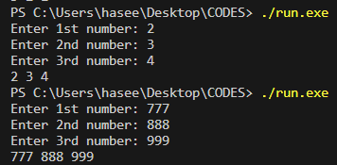

**3. Complex Questions: CLO [3]**

1. Create a C++ program for a simple calculator that takes two numbers and an operation **(+, -, *, /)** as input. Use if-else statements to perform the corresponding operation and display the result.

|  |
| --- |
| #include <iostream>  using namespace std;  int main(){  double a, b;  char operation;  cout << "Enter the 1st number: ";  cin >> a;  cout << "Enter the 2nd number: ";  cin >> b;  cout << "For operation Enter (*, /, +, -): ";  cin >> operation;  if(operation == '*'){  cout << a << " * " << b << " = " << (a * b);  }else if(operation == '+'){  cout << a << " + " << b << " = " << (a + b);  }else if(operation == '-'){  cout << a << " - " << b << " = " << (a - b);  }else if(operation == '/'){  if(b == 0){  cout << "undifine value.";  }else{  cout << a << " / " << b << " = " << (a / b);  }  }else{  cout << "Enter valid opitions.";  }  return 0;  } |

Output

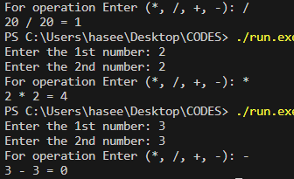

1. Design a C++ program that simulates a basic ATM. Ask the user to enter the account balance and the amount to withdraw. Use if-else statements to check if there is sufficient balance and display the result accordingly.

|  |
| --- |
| #include <iostream>  using namespace std;  int main(){  int account_balance ;  int withdraw_amount;  cout << "Enter account balance: ";  cin >> account_balance;  cout << "Enter withdraw amount: ";  cin >> withdraw_amount;  if (withdraw_amount > 0)  {  if(withdraw_amount <= account_balance){  account_balance -= withdraw_amount;  cout << "The withdraw balance is: " << withdraw_amount << "rs.\nThe remaining balance is: " << account_balance << "rs." << endl;  }else{  cout << "Insuffencet balance. Unable to withdraw.";  }  }else{  cout << "Invalid Withdraw amount.";  }  return 0;  } |

Output

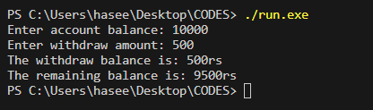

c) Write a C++ program to check whether a given number is a prime number or not. Use if-else statement to determine and display the result.

d) Develop a C++ program that acts as a simple guessing game. Generate a random number between 1 and 100 and ask the user to guess the number. Provide hints if the guess is too high or too low, and use if-else statements to determine when the correct guess is made.

|  |
| --- |
| #include <iostream>  #include <cstdlib>  using namespace std;  // Develop a C++ program that acts as a simple guessing game.  // Generate a random number between 1 and 100 and ask the user to guess the number.  // Provide hints if the guess is too high or too low, and  // use if-else statements to determine when the correct guess is made.  int main(){  int random_num = rand() % 100 + 1;  int guess;  cout << "Enter the guess number: ";  cin >> guess;  if(random_num == guess){  cout << "Congratulation!. You guess right.";  }else if(guess > random_num){  cout << "Too High. Try again.";  }else if(guess < random_num){  cout << "Too Low. Try again.";  }  return 0;  } |

Output

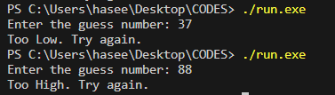

**Programming Fundamentals in C++ - Switch Statements**

Q1. Simple Questions: CLO [1]

1. **Write a C++ program using a switch statement to determine the day of the week based on the user's input. The program should prompt the user to enter a number between 1 and 7, where 1 represents Sunday, 2 represents Monday, and so on. Display an appropriate message indicating the corresponding day of the week.**

|  |
| --- |
| #include <iostream>  #include <cstdlib>  using namespace std;  int main(){  int daynum;  cout << "Enter the day number from 1 to 7: ";  cin >> daynum;  switch(daynum){  case 1:  cout << "Sunday";  break;  case 2:  cout << "Monday";  break;  case 3:  cout << "Tuesday";  break;  case 4:  cout << "Wednesday";  break;  case 5:  cout << "Thursday";  break;  case 6:  cout << "Friday";  break;  case 7:  cout << "Satureday";  break;  default:  cout << "Enter valid number.";  }  return 0;  } |

**Output**

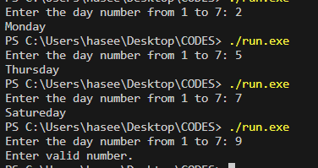

1. Create a C++ program that uses a switch statement to perform basic arithmetic operations. Prompt the user to enter two numbers and a choice (1 for addition, 2 for subtraction, 3 for multiplication, 4 for division). Perform the selected operation and display the result.

|  |
| --- |
| #include <iostream>  #include <cstdlib>  using namespace std;  int main(){     int  num, num2;     char operation;     cout << "Enter 1st number, Operation and 2nd number: ";     cin >> num >> operation >> num2;     switch(operation){      case '+':      cout << num << " + " << num2 << " = " << (num + num2);      break;      case '-':      cout << num << " - " << num2 << " = " << (num - num2);      break;      case '*':      cout << num << " * " << num2 << " = " << (num * num2);      break;      case '/':      if(num2 == 0){          cout << "Undefined number.";      }else{          cout << num << " / " << num2 << " = " << (num / num2);      }      break;     }      return 0;  } |

**Output**

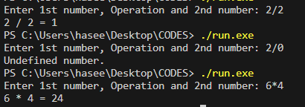

1. Design a C++ program to check if a given character is a vowel ('a', 'e', 'i', 'o', 'u') or a consonant using a switch statement. Prompt the user to enter a character, and then display whether it is a vowel or a consonant

|  |
| --- |
| #include <iostream>  using namespace std;  int main() {  char character;  cout << "Enter a character: ";  cin >> character;  switch (character){  case 'a':  case 'e':  case 'i':  case 'o':  case 'u':  cout << character << " is a vowel." << endl;  break;  default:  cout << character << " is a consonant." << endl;  }  return 0;  } |

**Output**

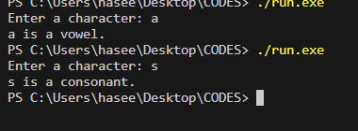

**Q2. Average Difficulty Questions: CLO [2]**

1. Develop a C++ program using a switch statement to calculate the area of different geometric shapes. Ask the user to choose between a square, circle, or triangle. Prompt for the necessary dimensions and display the calculated area**.**
2. **Hint: (Area = side * side)**, (**Area = π * radius * radius) and (Area = (base * height) / 2**

|  |
| --- |
| #include <iostream>  using namespace std;  int main() {  int choice;  double side, radius, base, height, area;  cout << "Choose a geometric shape to calculate the area:\n";  cout << "1. Square\n";  cout << "2. Circle\n";  cout << "3. Triangle\n";  cout << "Enter your choice (1, 2, or 3): ";  cin >> choice;  switch (choice) {  case 1:  cout << "Enter the side length of the square: ";  cin >> side;  area = side * side;  cout << "The area of the square is: " << area ;  break;  case 2:  cout << "Enter the radius of the circle: ";  cin >> radius;  area = 3.14 * radius * radius;  cout << "The area of the circle is: " << area;  break;  case 3:  cout << "Enter the base and height of the triangle: ";  cin >> base >> height;  area = (base * height) / 2;  cout << "The area of the triangle is: " << area;  break;  default:  cout << "Enter a valid choice (1, 2, or 3).\n";  break;  }  return 0;  } |

**Output**

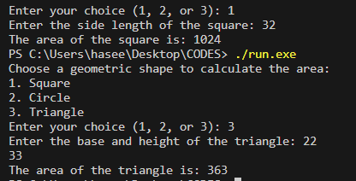

1. Write a C++ program to simulate a simple calculator that supports addition, subtraction, multiplication, and division using a switch statement. Allow the user to enter two numbers and choose the operation to perform.

|  |
| --- |
| #include <iostream>  #include <cstdlib>  using namespace std;  int main(){     int  num, num2;     char operation;     cout << "Enter 1st number, Operation and 2nd number: ";     cin >> num >> operation >> num2;     switch(operation){      case '+':      cout << num << " + " << num2 << " = " << (num + num2);      break;      case '-':      cout << num << " - " << num2 << " = " << (num - num2);      break;      case '*':      cout << num << " * " << num2 << " = " << (num * num2);      break;      case '/':      if(num2 == 0){          cout << "Undefined number.";      }else{          cout << num << " / " << num2 << " = " << (num / num2);      }      break;     }      return 0;  } |

**Output**



1. Create a C++ program to convert temperature units (Celsius to Fahrenheit and vice versa) using a switch statement. Prompt the user to choose the conversion type and input the temperature. Display the converted temperature.

|  |
| --- |
| #include <iostream>  using namespace std;  int main() {  double fahrenheit, celsius, C, F;  int choice;  cout << "Choose the conversion type:\n";  cout << "1. Fahrenheit to Celsius\n";  cout << "2. Celsius to Fahrenheit\n";  cout << "Enter your choice (1 or 2): ";  cin >> choice;  switch (choice) {  case 1:  cout << "Enter Fahrenheit: ";  cin >> fahrenheit;  C = (fahrenheit - 32) * 5 / 9;  cout << "Celsius is: " << C;  break;  case 2:  cout << "Enter Celsius: ";  cin >> celsius;  F = celsius * 9 / 5 + 32;  cout << "The Fahrenheit is: " << F;  break;  default:  cout << "Enter a valid input (1 or 2).";  break;  }  return 0;  } |

**Output**

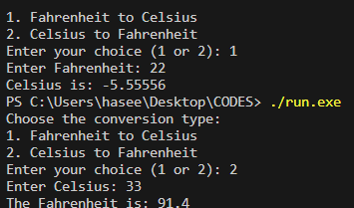

**3. Complex Questions: CLO [3]**

1. Develop a C++ program that simulates a small banking system. Implement a switch statement to offer options such as checking balance, deposit, withdrawal, and exit. Keep track of the account balance and perform the chosen operation accordingly

|  |
| --- |
| #include <iostream>  using namespace std;  int main() {  int account_balance;  int withdraw_amount;  cout << "Enter account balance: ";  cin >> account_balance;  cout << "Enter withdraw amount: ";  cin >> withdraw_amount;  if (withdraw_amount > 0) {  switch (withdraw_amount <= account_balance) {  case true:  account_balance -= withdraw_amount;  cout << "The withdraw balance is: " << withdraw_amount << "rs.\nThe remaining balance is: " << account_balance << "rs." << endl;  break;  case false:  cout << "Insufficient balance. Unable to withdraw.";  break;  }  } else {  cout << "Invalid Withdraw amount.";  }  return 0;  } |

**Output**

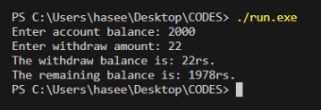

1. Write a C++ program to implement a simple game where the user guesses a number between 1 and 100. Use a switch statement to provide hints (too high, too low) based on the user's input until they guess the correct number. Display the number of attempts at the end.

|  |
| --- |
| #include <iostream>  #include <cstdlib>  using namespace std;  // Develop a C++ program that acts as a simple guessing game.  // Generate a random number between 1 and 100 and ask the user to guess the number.  // Provide hints if the guess is too high or too low, and  // use if-else statements to determine when the correct guess is made.  int main(){  int random_num = rand() % 100 + 1;  int guess;  cout << "Enter the guess number: ";  cin >> guess;  if(random_num == guess){  cout << "Congratulation!. You guess right.";  }else if(guess > random_num){  cout << "Too High. Try again.";  }else if(guess < random_num){  cout << "Too Low. Try again.";  }  return 0;  } |

**Output**

